# **Vision Statement**

Elad weinbrand 203306014, Sivan Namah Azari 208479311.

* Project goals- managing meals scheduler.

The app will provide information such as :

* Daily, weekly, monthly and yearly cost for a recipe.
* Daily, weekly, monthly and yearly amount of ingredients for a recipe.
* For each recipe, presenting the calories intake, amount of protein/fat/carbs
* Provide build in recipes

The app will give service such as :

* Managing recipes page created by the user
* Scheduling each day 3 meals (breakfast, lunch, dinner).
* Project scope-

The project is about managing and organizing food cost and plans.  
The project does not provide track of any kind about the user (such as diet, weight, etc.).

* High-level features or requirements:

|  |  |
| --- | --- |
| Essential: | Desirable: |
| * Daily, weekly, monthly and yearly cost for a recipe. | * For each recipe, presenting the calories intake, amount of protein/fat/carbs |
| * Daily, weekly, monthly and yearly amount of ingredients for a recipe. | * Search for recipe in the data base using key words and presenting the matching results |
| * Provide the users the option to add new recipe that was created by them | * Provide the option to share recipe between users. (There will be a page name "Shared recipes" that will present all the recipes that were shared by the users and not the default recipes provided by the app). |
| * Daily cost for an entire day meal plan | * Provide the option to create an event and add meals for further organization (for example upcoming birthday) |
| * Allowing the user to mark recipe as "favorite" and presenting them in different page. | * For each ingredient that is in the app, there will be an option to receive all the recipes that include that ingredient |
| * Present the way to store large quantities of food that the user buy (ways to store for a long time) | * For each ingredient that is in the app, there will be an option to receive all the information about it, cost, how to store it (optional – carbs, protein etc.) |
| * Present recipes of food that the ingredients are in season |  |
| * Daily, weekly, monthly and yearly shopping list for all meals (Note that the app will only provide the groceries list but the user wont be able to purchase the iteams). |  |

* Major milestones and deliverables:
* Client- Application or web page
* Programmer- Server , using sort of database
* For:
* Small/big institutions (such as the army, cafeterias, restaurants and more).
* Nutritionist (Who wants to plan a yearly meal schedule for their patients).
* Families
* Individuals
* Who: Managing users meals by cost, amount of ingredients, scheduling meals daily/weekly/monthly/yearly and more.
* The: "Meals scheduler" : is an application under the category of food, money manager(spent on food)
* That: Organized way to list meals ,get the cost, find new recipes and get the proper amount of ingredients needed for the recipe (daily/weekly/monthly/yearly, all up to the user choice).
* Unlike: Alternative application such as "KitchenPal", "MealPlanner", "Plateful" give similar features but they don’t include all the features together that we represented.  
  For example "KitchenPal" gives as build-in recipes, the cost & ingredient needed for each recipe, there isn’t an option to create our own recipe or select recipe in advanced for the week.  
  "MealPlanner" is a simple app for planning our meals in advanced. There are label of weeks, each week contains the days separated by meals, and we can book a recipe to each meal of the day. There isn’t an option to use build-in recipes, in order to book a recipe for each meal we need to create our own.  
  "Platefull" is a simple application to schedule lunch for each day in the week, its being picked up front by recipes that we either create our own or use the build in ones.  
  The recipes that are build in are just the name of the dish, in order to search the ingredients and how to do it, we need to look it up and like the page to the recipe in the application.

Key-words that were helpful in finding similar apps were - food, food cost, food planner, food organizer, meal planner, meals, kitchen management.

* Our product: summary –

For big or small institution, families or individuals who needs an application in managing their meals such as how to deal with big quantities of ingredients, the finance aspect, schedule each meal upfront. We offer a way to do all of the above, list meals from build-in recipes or create your own and get the cost for them in any version they want (daily, weekly, etc.). Unlike other application that are not offering the exact same things, some have build-in recipe, in some of them you can create your own. You can plan your meals up front but you cannot get the total price and quantities you need in an organized way. In our application we offer you a combination of those things in order to help you manage your meal schedule in the side of quantities and cost, and the scheduling of what to eat per meal in your day.

**KitchenPal :**

Shopping cart (we cannot buy, it’s the groceries we might need for the recipes

Suggested groceries that we might want

Ways to insert groceries into our shopping cart (note that we cannot buy from the app)

The cost of this recipe  
Note that it’s the total cost and we don’t have the cost per ingredient.

Recipes page

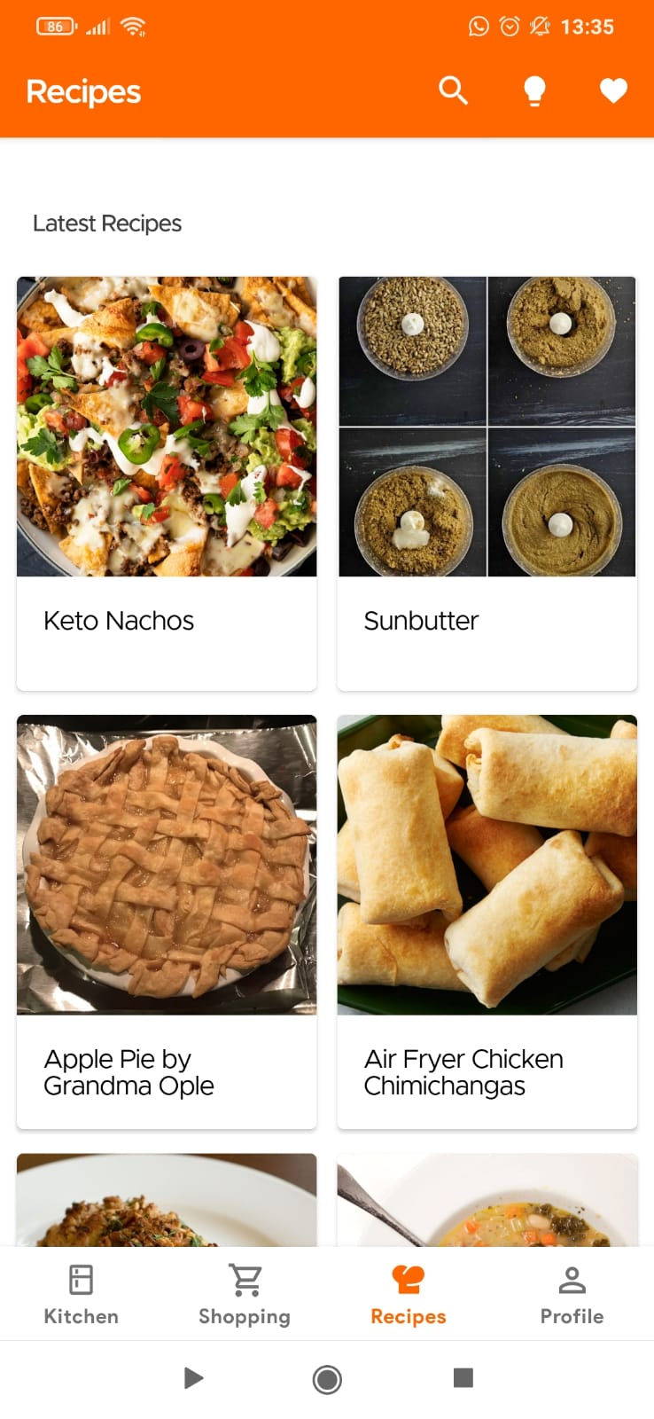

The ingredients needed for the recipe

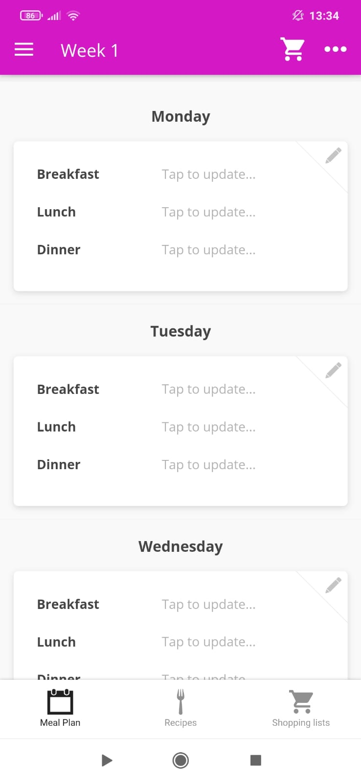

We can plan the meals for each day weeks ahead, each week will present the days with 3 meals separately

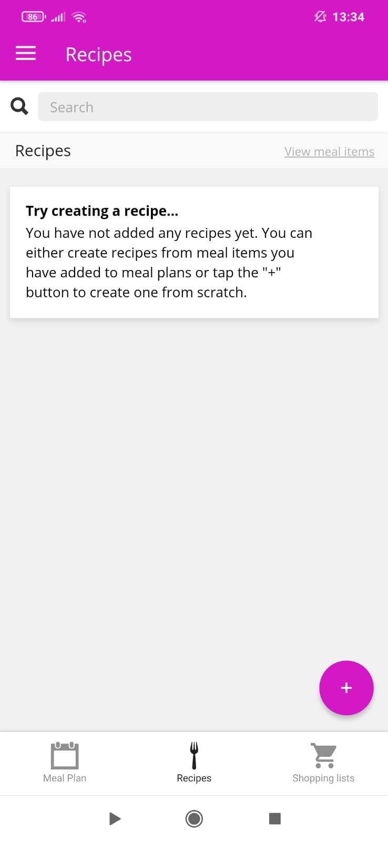

For example,

For Tuesday we can pick what each day we will eat

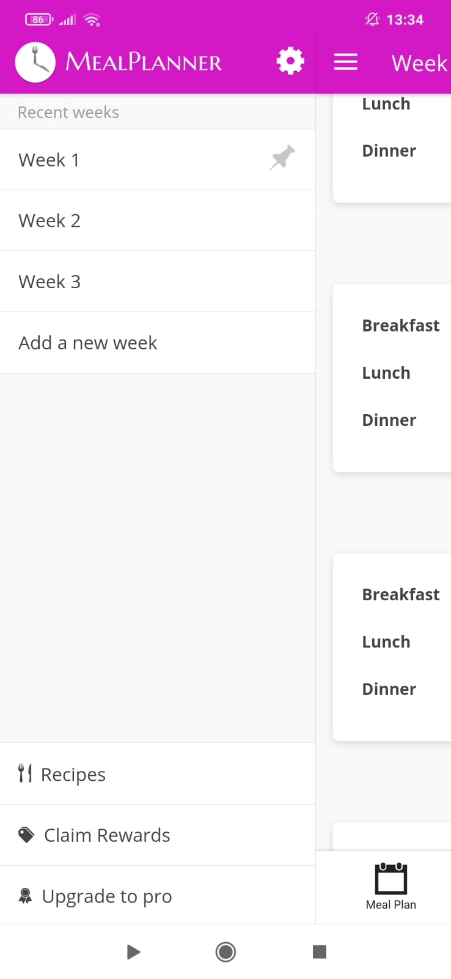

We create our own recipes

Bild-in recipes that we can use (only the name of the dish is given, for the recipe we need to look it up online and link it to the title

Creating a recipe, and then we can schedule it for lunch in the week

Presenting the days of the week and what to eat for lunch in each of them

Platefull